|  |
| --- |
| **Reports** (up to ~2500 words including references, notes and captions or ~3 printed pages) present important new research results of broad significance. Reports should include an abstract, an introductory paragraph, up to four figures or tables, and about 30 references. Materials and Methods should usually be included in [supplementary materials](http://www.sciencemag.org/site/feature/contribinfo/prep/prep_online.xhtml), which should also include information needed to support the paper's conclusions. |

The Importance of Early Attitudes Towards Mathematics and Science

A majority of student attitudes toward mathematics and science were stable from seventh through twelfth grade and related to outcomes such as mathematics and science achievement, STEM career attainment and support of science issues. Of the students who had less stable attitudes towards mathematics and science, changes in attitudes occurred prior to tenth grade which emphasizes the importance of encouraging and supporting early positive attitudes.

There are multiple goals to science education reforms such as the Next Generation Science Standards. One goal is to increase the number of qualified students who are interested in pursuing careers in science (Graham, Frederick, Byars-Winston, Hunter, & Handelsman, 2013; National Academy of Sciences, 2011; National Science Board, 2010). Another goal is to increase the science and technological literacy of all students to create a more informed general public that actively engages and supports scientific innovation and discovery (Feinstein, Allen, & Jenkins, 2013). Central to these multiple goals is improving all students’ attitudes towards science and mathematics (Osborne, Simon, & Collins, 2003).

There is evidence that there is a decline in student attitudes toward science (Breakwell & Beardsell, 1992; Yager and Penick 1986) and that student attitudes shift depending on factors such as who is teaching, what they are teaching and how they are teaching (Atwater, Wiggins, & Gardner, 1995; Ebenezer & Zoller, 1993; Osborne & Collins, 2000; Whitfield, 1980). There is also evidence that student attitudes toward science and mathematics are related to interest in STEM careers and academic behaviors related to science and mathematics (Atwater, Lance, Woodard, & Hillsman, 2013; Ing & Nylund, 2013; Sadler, Sonnert, Hazari, & Tai, 2012) and that differences in these outcomes are related to student characteristics such as gender and ethnicity (Calabrese Barton, Kang, Tan, O’Neill, Bautista-Guerra, & Brecklin, 2013; DeWitt, Archer, Osborne, Dillon, Willis, &Wong, 2011; Fadigan & Hammrich, 2004; Weinburgh, 1995). Despite calls to support early interest in science (Tai, Qi Liu, Maltese, & Fan, 2006) and efforts to improve interest in science such as professional development opportunities for science teachers (Supovitz & Turner, 2000), we know little about the long-term implications of these efforts to address declining student attitudes. This study explores how enduring and persistent early student attitudes are toward mathematics and science using a nationally representative, longitudinal data. In doing so, we address the following questions: 1) How stable are student attitudes towards mathematics and science from seventh through twelfth grade?; 2) Do students who are typically underrepresented in STEM fields change their attitudes toward mathematics and science more or less compared to other students?; and 3) Are changes in attitudes related to student achievement, STEM career persistence, and student interest and support for science-related issues? This study identifies grade levels where student attitudes might be particularly vulnerable to shifting and the extent to which attitudes towards mathematics and science are persistent for particular groups of students.

**Survey and Analysis**

We used the Longitudinal Study of American Youth (LSAY) for this study (Miller, 2010). The LSAY was funded by the National Science Foundation in 1986 to examine the development of student achievement in middle and high school and the relationship of those patterns to career choices. Annual data was collected starting in seventh grade and continuing one year beyond high school. Follow-up data collection efforts started in 2005 (when participants were in their mid-30’s).The cohort consists of students from 52 middle schools across the United States in 1987 (*N* = 3,116). Approximately 60 students were randomly selected from each school. The sample is predominantly White (70%) with approximately equal numbers of females (48%) and males (52%). The sample included 9% Hispanic, 11% African American, 4% Asian, and 2% Native American (5% of students did not indicate any race/ethnicity). Students who are typically underrepresented in STEM fields (Hispanic, African American, Native American) are classified as underrepresented in this study (National Science Foundation, 2013). Thirty-one percent of the students in the sample had at least one parent who completed college, while the other 69% did not. By 2007, more than 95% of the original sample completed a questionnaire about their educational and occupational outcomes (Miller & Kimmel, 2012).

We analyzed the longitudinal student attitudinal data toward mathematics and science from seventh grade, tenth grade and twelfth grade using latent transition analysis (LTA; Collins & Wugalter, 1992; Nylund, 2007; Nylund, Asparouhov, & Muthén, 2007). LTA is a longitudinal model that allows for both the identification of profiles at each time point, as well as modeling change in profiles that occurred within individuals across time. In addition, LTA profiles can be linked to auxiliary information to describe and compare trajectory profiles. We related the trajectory profiles to demographic information (ethnicity, gender) and outcomes (student science and mathematics achievement, students’ perceived interest and support of science-related issues, and whether or not students’ attained a STEM career by their mid-30’s).

**Results and Discussion**

Four attitudinal profiles were identified that varied in their affinity towards math and science (see Figure 1 for seventh grade attitudinal profile). These attitudinal profiles were labeled as: positive, qualified positive, indifferent, and dim. These labels reflect the probability of students in each class endorsing particular items. For example, as shown in Figure 1, students in the positive class were more likely to endorse all of the items compared to students in the qualified positive, indifferent and dim classes; while students in the dim class were less likely to endorse all of the items compared to students in the positive, qualified positive and indifferent classes. These four profiles were consistent across seventh, tenth and twelfth grade, though the relative size of each of the profiles differed (Figure 2). For example, students who had consistently positive attitudes towards math and science ranged in size between 26%-35% of the sample. There were also student who didn’t like math or science (between 18%-21%, *Dim*), and a class that was indifferent (between 24% and 29%, *Indifferent*). There were also students with qualified positive attitudes—that is, they liked math but not science (21%-27%). Though the relative size of the classes remained relatively stable, our results revealed that for some students, their attitudes towards math and since changed over time --some in a positive direction, some in a detrimental direction.

These attitudinal profiles were consistently related to mathematics and science achievement. In other words, students with more positive attitudes toward science were also students who performed higher on the science achievement measures at each grade level. Attitudinal profiles were related to gender but not ethnicity. For example, in seventh grade, 26% of all females were in the positive class compared to 35% of males. There were more females in the qualified positive class (40%) compared to males (30%) and similar percentages of males and females in the indifferent and dim class in seventh grade. This pattern of more males in the positive attitudinal profile compared to females persisted through twelfth grade.

**Stability of attitudes**. The stability of the four attitudinal profiles at each grade level varied over time (Figure 2). Attitudes are enduring and persistent for 60% of the sample but not for the remaining 40%. 18% of all students were consistently in the positive attitudinal profile from seventh through twelfth grade; 15% were consistently in the qualified positive attitudinal profile from seventh through twelfth grade and 46% of all students were consistently in the dim or indifferent class. For students who changed their attitudes over time, knowing where they started in seventh grade or knowing where the ended in twelfth grade was not sufficient to describe the movement of students through the pipeline. For example, although 31% of the students were in the positive class in seventh grade and 32% were in the positive class in twelfth grade, this doesn’t describe which students were in the positive class in seventh grade and how many of them continued to be in the positive class in twelfth grade. Results indicate that 66% of the students who were in the positive class in seventh grade remained in the positive class in tenth grade. Of those who were in the positive class in seventh grade and tenth grade, 85% were still in the positive class in twelfth grade. However, the remaining 34% of the students who were in the positive class in seventh grade did not end up in the positive class in twelfth grade. While this pattern is consistent with the notion that student attitudes toward mathematics and science tend to decline or decrease over time there were also students who started off in the dim class in seventh grade but moved to more positive attitudes in tenth and twelfth grade. This indicates that attitudes can change both in both positive and negative directions.

There is greater stability in the attitudinal profiles from tenth to twelfth grades compared to seventh to tenth grade. For example, if 91% of the students who were in the dim class in tenth grade were in the dim class in twelfth grade compared to 68% of the students who were in the dim class in seventh grade and dim class in tenth grade. This suggests that as student’s progress through high school, there is greater stability in attitudes towards mathematics and science. However the early instability of the four attitudinal profiles is encouraging for educators in that attitudes toward mathematics and science are not necessarily consistent and thus a malleable factor that can be influenced as students’ progress through middle and high school.

**Attitudinal profiles related to gender and ethnicity**. To better understand the characteristics of students in these different attitudinal profiles we related demographic and achievement information to the different trajectories (see Online Supplementary Materials). Overall, gender and ethnicity was not related to whether or not students changed their attitudinal profiles over time. For example, females were not more or less likely than males to change their attitudinal profiles over time (*b* = .14, *z*(3,009) = 1.94, *p* = .05, *Odds Ratio* = 1.15). 61% of males and 58% of females were stable in their attitudinal profiles and 39% of males and 42% of females changed their attitudinal profiles (χ2(1, *N* = 3,099) = 3.75, *p* = .05).

In addition to knowing which students changed their attitudes and which students did not change their attitudes, it is important to consider what changes occurred and when these changes are happening more frequently for certain groups of students compared to others. Females who did not change their attitudes were in either the indifferent or qualified positive groups (20%) or the dim group (23%). Of the females who changed attitudinal profiles, 11% started in the positive group but ended in the qualified positive or indifferent group and 11% start off in the dim group and moved to the positive or qualified positive group. Males who did not change, on the other hand, were more likely to be in the dim group (26%) or the positive group (22%) rather than the indifferent or qualified positive groups (13%). Of the males of did change, 13% started off in the positive group but ended in the qualified positive or indifferent group and 9% started in the dim group but ended in the positive or qualified positive group. Figure 3 provides a comparison of females and males who started in the dim attitudinal profile in seventh grade. Although most students continued in the dim attitudinal profile in tenth grade (66% of females and 70% of males), 8% transitioned to a positive attitudinal profile in tenth grade, and 93% of those females continued to have a positive attitude in twelfth grade and 86% of males continued to have a positive attitude in twelfth grade. This suggests that attitudes are fairly stable across gender and ethnicity but that changes to these early attitudes towards mathematics and science (prior to tenth grade) could be productive.

**Attitudinal trajectories related to STEM career persistence.** Students with consistent attitudes were not more or less likely to attain STEM careers (χ2(1, *N* = 3,099) = 0.03, *p* = .85). However, 37% of the students with consistently *positive* attitudes were employed in a STEM career by their mid-30’s. The importance of a consistently positive attitude toward mathematics and science and STEM career persistence is supported by other research that suggests that students need to succeed in challenging mathematics and science coursework throughout their high school years to prepare them to succeed in college (Bottia, Stearns, Mickelson, Moller, & Paker, 2014; Engberg & Wolniak, 2013; Tai, Qi Liu, Maltese, & Fan, 2006). Students who were consistently low in their attitudes toward mathematics and science were not likely to persist in a STEM career (7%) but students who started with a low attitude in seventh grade but changed to a more positive attitude in twelfth grade were more likely to persist in a STEM career (29%). This suggests that although student attitudes might be more enduring or consistent for some students, it is also possible that student attitudes can change, and if they do change toward more positive attitudes, this increases the likelihood that the students will be prepared and interested to pursue STEM careers. Even if students are not interested in science in seventh grade, it is still possible for them to change their attitudes and end up in twelfth grade with more positive attitudes toward science.

**Attitudinal trajectories related to support of science**. In addition to whether students are interested and qualified to pursue STEM careers, there is also a need to encourage all students to be interested in science-related issues. Not all students will become scientists or engineers but all students will make decisions in their daily lives that require some reasoning and participation around medical or environmental issues (Feinstein, Allen, & Jenkins, 2013). 46% of the students in the consistently positive attitudinal trajectory expressed positive opinions and support of science compared to 32% in the consistently dim attitudinal trajectory and 28% in the consistently indifferent or qualified positive trajectories. While those with positive attitudes are more likely to express support of science, this percentage is low considering the inclination to encourage scientific literacy for all students regardless of whether or not they actually pursue STEM careers. Students who started with positive attitudes in seventh grade but transitioned to less positive attitudes were not supportive of science in twelfth grade (38% who started high and ended low; 22% who started high and ended medium).

These results highlight the importance of supporting and sustaining early attitudes in mathematics and science. Prior research suggests that differences in achievement does not address differences in STEM career attainment (Riegle-Crumb, King, Grodsky, & Muller, 2012) and that other factors, such as attitudes towards mathematics and science can influence interest and persistence in STEM careers (Simpson & Oliver 1985). In this study, we found that for a majority of students, attitudes towards mathematics and science were fairly consistent or resistant to change from seventh through twelfth grade. However, we also found that it was also not a guarantee that an early positive attitude will sustain through high school (Osborne, Simon, & Collins, 2003; Sadler, Sonnert, Hazari, & Tai, 2012). In fact, it is more likely that student’s attitudes change the most between seventh and tenth grade but do not change after tenth grade (Aschbacher, Li, & Roth, 2010). The consistency of these findings across demographic characteristics suggests that student attitudes can change but as students get older, they are less likely to change their attitudes. Thus, it is important to consider not just whether or not a student has a particular attitudinal profile in a single grade level but to look across multiple years to better understand where students are coming from and where they can go. Attitudinal profiles were related to outcomes such as achievement. We note that although one goal is to encourage and support more students to be qualified to pursue STEM careers another important goal is to create a more informed general public who supports scientific innovations. Thus, supporting and sustaining early positive attitudes toward mathematics and science is necessary to achieve both of these goals.

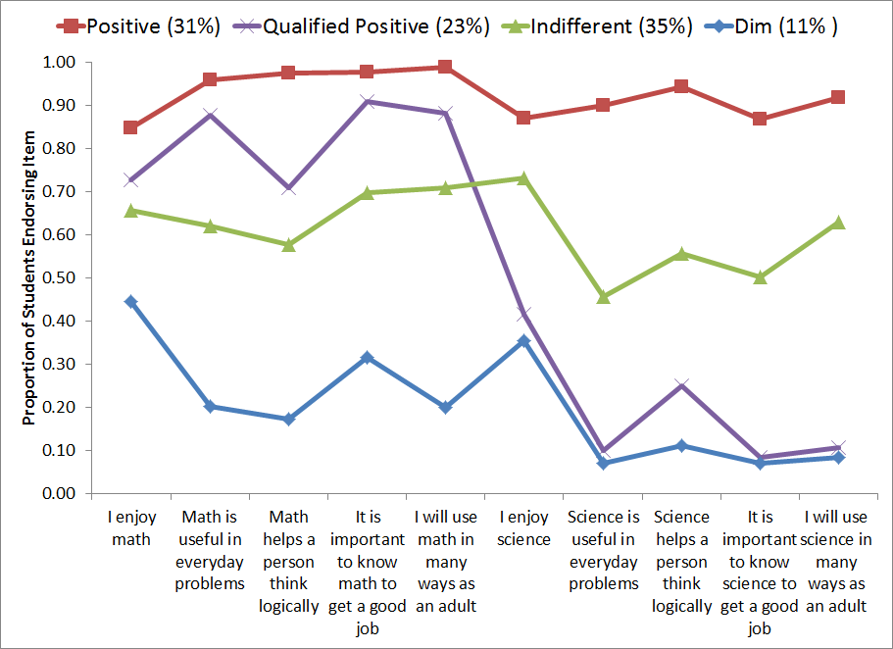

*Figure 1*. Item probability profiles by latent class attitudinal profile in grade 7.

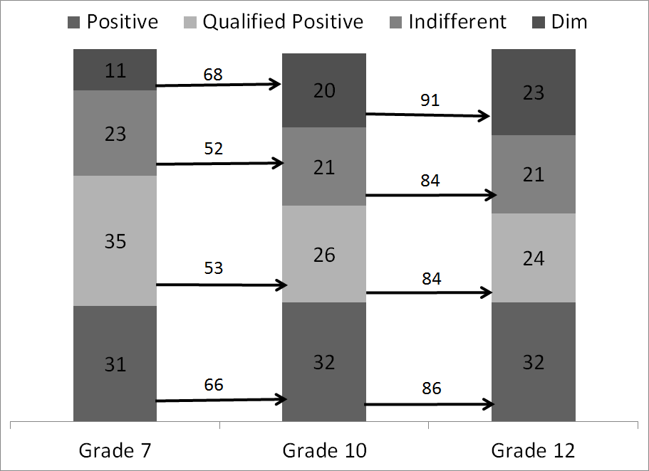

*Figure 2*. Percent of students in each attitudinal profile in grade 7, 10 and 12. The numbers above the arrows indicate the path from one year to the next for the most likely attitudinal profile. For example, 31% of students in grade 7 were in the *Positive* attitudinal profiles and 66% of those students were also in the *Positive* attitudinal profile in grade 10.

|  |  |
| --- | --- |
| Females | Males |

*Figure 3*. Percent of females and males in each attitudinal profile in grade 7, 10 and 12. The numbers in the circles represent the percent of students in each profile for that particular year. The numbers above the arrows represent the percent of students who moved from one attitudinal profile to another for students who were in the *Dim* attitudinal profile in grade 7.

**References**

Aschbacher, P. R., Li, E., & Roth, E. J. (2010). Is science me? High school students’ identities, participation and aspirations in science, engineering, and medicine. *Journal of Research in Science Teaching*, *47*(5), 564–582.

Atwater, M. M., Lance, J., Woodard, U., & Hillman, N. (2013). Race and ethnicity: Powerful forecasters of science learning and performance. *Theory into Practice*, *52*(1), 6-13.

Atwater, M. M., Wiggins, J., & Gardner, C. M. (1995). A study of urban middle school students with high and low attitudes toward science. *Journal of Research in Science Teaching*, *32*(6), 665–677.

Bottia, M., Stearns, E., Mickelson, R., & Moller, S. (2014). Do experiences of inspiration/reinforcement and preparation during high school increase the likelihood of declaring a STEM major? *Teachers College Record*.

Breakwell, G. M., & Beardsell, S. (1992). Gender, parental and peer influences upon science attitudes and activities. *Public Understanding of Science*, *1*(2), 183–197.

Calabrese Barton, A., Kang, H., Tan, E., O’Neill, T. B., Bautista-Guerra, J., & Brecklin, C. (2013). Crafting a future in science: Tracing middle school girls’ identity work over time and space. *American Educational Research Journal*, *50*(1), 37-75.

Catsambis, S. (1995). Gender, race, ethnicity and science education in the middle grades. *Journal of Research on Science Teaching*, *32*, 243–257.

Collins, L.M. & Wugalter, S.E. (1992). Latent class models for stage-sequential dynamic latent variables. *Multivariate Behavioral Research*, *27*, 131-157.

DeWitt, J., Archer, L., Osborne, J., Dillon, J.,Willis, B., &Wong, B. (2011). High aspirations but low progression: The science aspirations-careers paradox among minority ethnic students. *International Journal of Science and Mathematics Education*, *9*(2), 243–271.

Ebenezer, J. V., & Zoller, U. (1993). Grade 10 students’ perceptions of and attitudes toward science teaching and school science. *Journal of Research in Science Teaching*, *30*(2), 175–186.

Engberg, M. E., & Wolniak, G. C. (2013). College student pathways to the STEM disciplines. *Teachers College Record*, *115*(1), 1-27.

Fadigan, K. A., & Hammrich, P. L. (2004). A longitudinal study of the educational and career trajectories of female participants of an urban informal science education program. *Journal of Research in Science Teaching*, *41*(8), 835–860.

Feinstein, N.R., Allen, S., & Jenkins, E. (2013). Outside the pipeline: Reimagining science education for nonscientists. *Science*, *340*(6130), 314-317.

Graham, M. J., Frederick, J., Byars-Winston, A., Hunter, A-B., & Handelsman, J. (2013). Increasing persistence of college students in STEM. *Science*, *341*(6153), 1455-1456.

Ing, M., & Nylund-Gibson, K. (2013). Linking early science and mathematics attitudes to long-term science, technology, engineering, and mathematics career attainment: Latent class analysis with proximal and distal outcomes. *Educational Research and Evaluation*, *19*(6), 510-524.

Miller, J. D. (2010). *Longitudinal Study of American Youth, 1987–1994, and 2007*. Ann Arbor, MI: Inter-University Consortium for Political and Social Research.

Miller, J. D., & Kimmel, L. G. (2012). Pathways to a STEMM profession. *Peabody Journal of Education*, *87*(1), 26-45.

National Academy of Sciences. (2011). *Expanding underrepresented minority participation: America’s science and technology talent at the crossroads*. Washington, DC: Author.

National Science Board. (2010). *Preparing the next generation of STEM innovators: Identifying and developing our nation’s human capital*. Arlington, VA: National Science Foundation.

National Science Foundation. (2013). *Women, minorities, and persons with disabilities in science and engineering: 2013* (NSF 13–304). Arlington, VA: National Science Foundation.

Nylund, K. (2007). *Latent transition analysis: Modeling extensions and an application to peer victimization*. (Unpublished doctoral dissertation). University of California, Los Angeles; Los Angeles, CA.

Nylund, K. L., Asparouhov, T., & Muthén, B. O. (2007). Deciding on the number of classes in latent class analysis and growth mixture modeling: A Monte Carlo simulation study. *Structural Equation Modeling: A Multidisciplinary Journal*, *14*(4), 535–569.

Osborne, J., Simon, S., & Collins, S. (2003). Attitudes toward science: A review of the literature and its implications. *International Journal of Science Education*, *25*(9), 1049-1079.

Riegle-Crumb, C., King, B., Grodsky, E., & Muller, C. (2012). The more things change, the more they stay the same? Prior achievement fails to explain gender inequality in entry into STEM college majors over time. *American Educational Research Journal*, *49*, 1048–1073.

Sadler, P. M., Sonnert, G., Hazari, Z., & Tai, R. (2012). Stability and volatility of STEM career interest in high school: A gender study. *Science Education*, *96*(3), 411-427.

Simpson, R. D., & Oliver, J. S. (1985). Attitude toward science and achievement motivation profiles of male and female science students in grades six through ten. *Science Education*, *69*, 511–526.

Supovitz, J. A., & Turner, H. M. (2000). The effects of professional development on science teaching practices and classroom culture. *Journal of Research in Science Teaching*, *37*(9), 963-980.

Tai, R. H., Qi Liu, C., Maltese, A. V., & Fan, X. (2006). Planning early for careers in science. *Science*, *312*, 1143–1144.

Weinburgh, M. (1995). Gender differences in student attitudes toward science: A meta-analysis of the literature from 1970 to 1991. *Journal of Research in Science Teaching*, *32*(4), 387-398.

Yager, R. E., & Penick, J. E. (1986). Perception of four age groups toward science classes, teachers, and the value of science. *Science and Education*, *70*(4), 355–363.